Comparative study of regression models for customer lifetime value prediction
A Regression Analysis of E-Commerce Behavioural and Transactional Data

Abstract
Customer Lifetime Value (LTV) is one of the most important metrics in e-commerce because it can help businesses identify high-value customers and develop marketing strategies. In this study, we report results from a head-to-head comparison of five regression techniques — OLS applied to original variables versus OLS on transformed variables, Ridge Regression, Principal Component Regression (PCR) and Random Forest applied to a synthetic dataset with 50K e-commerce customer records consisting of 25 behavioural and transactional features. The dataset had major right-skewness (skewness = 1.45) in target variable, and extreme multicollinearity between engineered features, an organized transformation pipeline containing log-transformation, Yeo-Johnson power transformation, Winsorization and standardization. The R² for the baseline OLS model was 0.4948, constrained itself by the order from heteroscedasticity and non-normality of residuals. An R² = 0.9121 out of OLS post-transformation along with Ridge Regression (alpha = 1.757) produced exactly the same result, further reinforcing that multicollinearity present in this data was largely structural and therefore not as easily penalizable. For PCR, R² = 0.4504 (17 components explaining 90.4% of variance); however, its performance was modest due to information loss through dimensionality reduction. Random Forest performed the best with R² = 0.9775 and RMSE = 0.0975 on log-LTV,

Keywords: customer lifetime value; regression analysis; random forest; ridge regression; principal component regression; multicollinearity; feature transformation

1. Introduction
Customers rely on Lifetime Value (LTV) to help identify their best customers over their entire relationship. For example, in e-commerce where the cost of customer acquisition and retention is high, the right model can help segment customers, deliver personalized recommendations, and maximize channel investment [1]. But, while the LTV prediction is an important task, it is challenging to predict because the data are complex with high levels of data, predictors are correlated and statistically biased, and there may be nonlinear relationships that linear models may miss [2].
Linear regression in its various forms is used widely because of its interpretability and tractability. The choice of linear regression depends upon homoscedasticity, normality of residuals, and the absence of severe multicollinearity [3]. If these assumptions are violated, as occurs with transactional data, then a corrective action is to change the variables or normalize the data or reduce the size of the data. Alternatively, we might consider leaving linearity behind and choosing ensemble methods such as Random Forest, which capture complex interactions at the cost of interpretability [4].
We analyze 50,000 observations of e-commerce data for comparison with the five regression strategies: (1) OLS on the original variables, (2) OLS on the transformed and normalized feature space, (3) Ridge Regression to correct multicollinearity through L2 penalty, (4) Principal Component Regression (PCR) to reduce dimensionality, and (5) Random Forest as a nonparametric benchmark. We investigate the questions: (i) How much does data transformation improve linear regression performance for skewed LTV data? (ii) Does Ridge Regression perform better than transformed OLS when multicollinearity exists? (ii) How does PCR compare with PCR when significant variance is concentrated in a smaller component space?
(iv) What is the performance ceiling of a non-parametric ensemble? What features drive the predictions?
What we want to address here is the lack of systematic head-to-head comparisons among these five model families on behavioral e-commerce data with diagnostics at each stage. These studies typically compare two or three models without reporting on the transformation or effects on regression assumptions [5]. We aim to fill this gap by providing a reproducible and diagnostic-rich analysis.

2. Materials and Methods

2.1 Dataset Description
The dataset consists of 50,000 synthetic e-commerce customer records with 25 features spanning demographics, transactional behavior, digital engagement, and customer service interactions. The target variable is Lifetime_Value (LTV), representing cumulative customer revenue. Key features include Total_Purchases, Average_Order_Value, Membership_Years, Session_Duration_Avg, Pages_Per_Session, Login_Frequency, Cart_Abandonment_Rate, Returns_Rate, Email_Open_Rate, Mobile_App_Usage, Product_Reviews_Written, Wishlist_Items, Social_Media_Engagement_Score, Credit_Balance, Discount_Usage_Rate, Customer_Service_Calls, Payment_Method_Diversity, and the categorical indicator Signup_Quarter_Q4.
The target variable exhibited a mean of $1,440.63 (median = $1,243.41, std = $907.25) with a skewness of 1.45 and kurtosis of 3.27, indicating a right-skewed, leptokurtic distribution. Fourteen of 24 numeric features exhibited absolute skewness greater than 1.

2.2 Data Preprocessing
Missing values were present in 14 of 25 features, totaling 49,081 entries (3.9% of all cells). All missing values were imputed using the column median, chosen for its robustness to outliers. Following imputation, three composite features were engineered:
- $Engagement_Index=(Session_Duration_Avg × Pages_Per_Session)$,
- $Purchase_Recency =(1 / (Days_Since_Last_Purchase + 1)),$ and
- $Loyalty_Ratio =(Total_Purchases / (Membership_Years + 1))$
The final feature matrix comprised 27 predictors for 50,000 observations.

2.3 Multicollinearity Assessment
Multicollinearity refers to a situation in multiple regression where two or more independent variables are highly linearly correlated.
Why is multicollinearity a problem: Inflates variance of coefficient estimates, makes coefficients unstable and sensitive to small data changes, reduces interpretability of individual predictors and leads to misleading statistical inference (high p-values despite real effects).

2.3.1 Variance Inflation Factor (VIF)
VIF measures how much the variance of a regression coefficient is inflated due to multicollinearity.
Formula: $VIF_{j}​=1/1-R_{j}^{2}​$
where $R_{j}^{2}$= R² from regression of $X_{j}$on all other predictors.
Why VIF was used: Among various methods such as (correlation matrix, condition index, eigenvalues), VIF was used in this study because:
Direct Interpretability: Provides a numeric measure of how much variance is inflated
Feature-specific diagnosis: Identifies which exact variable is problematic & unlike correlation matrices which only show pairwise relationships
Standard in regression analysis: Widely accepted diagnostic tool in econometrics and statistics
Quantifies severity: Allows threshold-based decisions (e.g., VIF > 10)

Variance Inflation Factors (VIF) were computed for all 27 features prior to modeling. A VIF exceeding 10 indicates high multicollinearity. Eight features exceeded this threshold, with Engagement_Index, reaching VIF = 70.05 due to its construction from Session_Duration_Avg and Pages_Per_Session. Despite this, all features were retained to preserve interpretability and because Ridge Regression and PCR were designed to handle collinearity explicitly.

2.4 Transformation Pipeline
To address violations of OLS assumptions, a four-stage transformation pipeline was applied: (1) Log-transformation of the target variable (LTV), reducing skewness from 1.45 to -0.67; (2) Yeo-Johnson power transformation applied to 14 right-skewed features; (3) Winsorization at the 1st and 99th percentiles to limit extreme outlier influence; and (4) Standardization (z-score scaling, mean=0, std=1) of all 27 features. Transformations were fitted on the training set and applied to the test set to prevent data leakage.

2.5 Model Specifications

2.5.1 OLS Regression (Original Variables)
Ordinary Least Squares (OLS) regression estimates the linear relationship between a dependent variable and multiple independent variables by minimizing the sum of squared residuals.
Model: $Y=β_{0}​+β_{1}​X_{1}​+β_{2}​X_{2}​+⋯+β_{k}​X_{k}​+ϵ$
- Y: Dependent variable
- $X_{i}$: Independent variables
- $β_{i}$: Coefficients
- $ϵ$: Error term
For the Ordinary Least Squares (OLS) regression model to produce reliable, unbiased, and efficient estimates, several key assumptions must be satisfied. These assumptions ensure the validity of statistical inference and the interpretability of model coefficients.
- The OLS model assumes a linear relationship between the dependent variable and the independent variables. This implies that the expected value of the response variable can be expressed as a linear combination of the predictors.
$E(Y∣X)=β0​+β1​X1​+⋯+βk​Xk​$
- Independence of Errors: The error terms (ϵ) are assumed to be independent of each other, meaning that the residual for one observation does not influence another.
- Homoskedasticity: The variance of the error term is assumed to be constant across all levels of the independent variables.
$Var(ϵ∣X)=σ2$
- Normality of Errors: The residuals are assumed to follow a normal distribution.
- No multicollinearity: Independent variables should not be highly linearly correlated with each other.
A standard multiple linear regression was estimated via statsmodels OLS on the raw, unscaled feature matrix. This served as the diagnostic baseline to expose assumption violations.

2.5.2 OLS Regression (Transformed Variables)
Model: $log\left(LTV\right)=β_{0}​+\sum{}β_{i}​X_{i}​+ϵ$
Same assumptions as OLS but better satisfied after transformation.
OLS was re-estimated on the transformed feature space with log(LTV) as the response. The model was estimated using an 80/20 train-test split with identical random state across all models.

2.5.3 Ridge Regression
Ridge Regression adds an L2 penalty (λ||β||²) to the OLS loss function, shrinking coefficients toward zero and reducing variance at the cost of a small bias.
Model: $min\sum{}{\left(y-y​\right)}^{2}+λ\sum{}β_{i}^{2}​$
- $λ$(alpha): Regularization parameter
- L2 penalty: Sum of squared coefficients
Used to improve generalization when predictors are highly correlated.
Assumptions: Same as linear regression (but more robust to multicollinearity)
The regularization parameter alpha was selected via 10-fold cross-validation over a logarithmic grid from 0.001 to 100, yielding an optimal alpha of 1.757

2.5.4 Principal Component Regression (PCR)
PCR first applies Principal Component Analysis (PCA) to reduce dimensionality, then performs regression on the selected principal components.
- Model: PCA transformation: $Z=XW$
- Regression: $Y=β_{0}+β_{1}Z_{1}+⋯+β_{m}Z_{m}+ϵ$
PCR first applies PCA to the standardized feature matrix, retaining components that explain 90% of cumulative variance (17 components, explaining 90.4%). OLS is then fitted on the reduced component space. PCR addresses multicollinearity by construction but loses direct feature interpretability.

2.5.5 Random Forest Regression
Random Forest is an ensemble learning method that builds multiple decision trees and averages their predictions to improve accuracy and robustness.
Model: $y^{​}=1/T\sum_{t=1}^{T}{}​f_{t}​\left(X\right)$
A Random Forest with 100 estimators was trained on the transformed feature space using default hyperparameters. Random Forest is a non-parametric ensemble method that averages predictions from independently trained decision trees, making it robust to outliers, non-linearities, and interactions without feature transformation requirements.
2.6 Statistical Significance Tests:

2.6.1 F-Test (Overall Significance Test):
The F-test is used to evaluate the overall significance of the regression model, i.e., whether the set of independent variables collectively explains a significant portion of the variation in the dependent variable.

$[H_0: \backslash beta_1 = \backslash beta_2 = \backslash cdots = \backslash beta_k = 0][H_1: \backslash text\{At least one \} \backslash beta_i \backslash neq 0]$

2.7 Evaluation Framework
All models were evaluated on a held-out 20% test set (10,000 observations). Performance metrics included R² (coefficient of determination), Adjusted R², Root Mean Squared Error (RMSE), Mean Absolute Error (MAE), and 10-fold cross-validation R² with standard deviation. OLS models were additionally assessed via F-test (overall significance), t-tests (variable significance), residual skewness and kurtosis, Q-Q plots, and residuals-vs-fitted plots.

3. Results

3.1 Multicollinearity Analysis
VIF analysis revealed severe multicollinearity in the engineered composite features. Engagement_Index had the highest VIF at 70.05, followed by Loyalty_Ratio (32.20), Pages_Per_Session (25.68), and Session_Duration_Avg (22.21). Eight features exceeded VIF = 10. In contrast, non-composite behavioral features such as Mobile_App_Usage (VIF = 3.13), Login_Frequency (2.48), and Cart_Abandonment_Rate (2.42) showed low collinearity. The pattern confirmed that multicollinearity originated from the mathematical construction of composite features rather than true redundancy among the original behavioral measurements.

Table 1. Top 10 Features by VIF Score (Multicollinearity Assessment)
Feature | VIF Score | Interpretation
Engagement_Index | 70.05 | High (>10) ✗
Loyalty_Ratio | 32.20 | High (>10) ✗
Pages_Per_Session | 25.68 | High (>10) ✗
Session_Duration_Avg | 22.21 | High (>10) ✗
Days_Since_Last_Purchase | 18.29 | High (>10) ✗
Purchase_Recency | 18.29 | High (>10) ✗
Total_Purchases | 18.21 | High (>10) ✗
Membership_Years | 16.73 | High (>10) ✗
Mobile_App_Usage | 3.13 | Low (<5) ✓
Login_Frequency | 2.48 | Low (<5) ✓

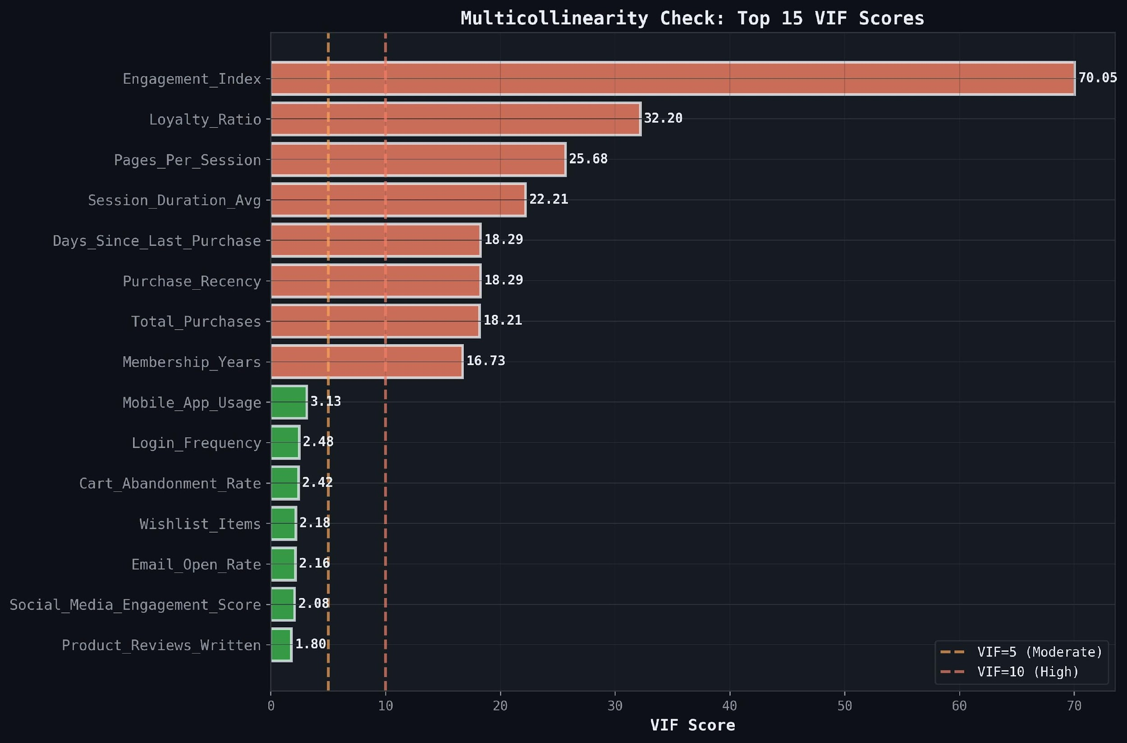
Figure 1. Top 15 VIF scores across all predictors. Red bars (VIF > 10) indicate severe multicollinearity requiring remediation; green bars (VIF < 5) indicate acceptable levels.

3.2 OLS Regression on Original Variables

3.2.1 Model Performance
The baseline OLS model achieved an R² of 0.4948 and adjusted R² of 0.4940, explaining approximately 49.5% of variance in LTV. The 10-fold cross-validation mean R² was 0.4846 (±0.0336), indicating moderate stability. The overall F-statistic was 1,889.69 (p < 0.001), confirming the joint significance of the predictors.

3.2.2 Variable Significance
Of the 27 predictors, 16 were statistically significant at p < 0.05. Total_Purchases had the largest absolute t-statistic (96.85), confirming it as the dominant driver of LTV. Average_Order_Value (t = 47.44), Loyalty_Ratio (t = -41.07), and Signup_Quarter_Q4 (t = -32.12) were also highly significant. The negative coefficient for Loyalty_Ratio (-62.40) and Membership_Years (-51.45) in the raw scale reflected complex scale effects that became more interpretable after standardization.

Table 2. Top 10 Coefficients — OLS (Original Variables)
Variable | Coefficient | Std Error | T-Stat | Significant
Total_Purchases | 97.44 | 1.006 | 96.85 | Yes ***
Average_Order_Value | 0.772 | 0.016 | 47.44 | Yes ***
Loyalty_Ratio | -62.40 | 1.519 | -41.07 | Yes ***
Signup_Quarter_Q4 | -275.27 | 8.569 | -32.12 | Yes ***
Membership_Years | -51.45 | 1.938 | -26.55 | Yes ***
Returns_Rate | -14.76 | 0.559 | -26.41 | Yes ***
const | 423.40 | 34.496 | 12.27 | Yes ***
Cart_Abandonment_Rate | -1.78 | 0.270 | -6.58 | Yes ***
Product_Reviews_Written | 9.42 | 1.645 | 5.72 | Yes ***
Wishlist_Items | 7.30 | 1.313 | 5.56 | Yes ***

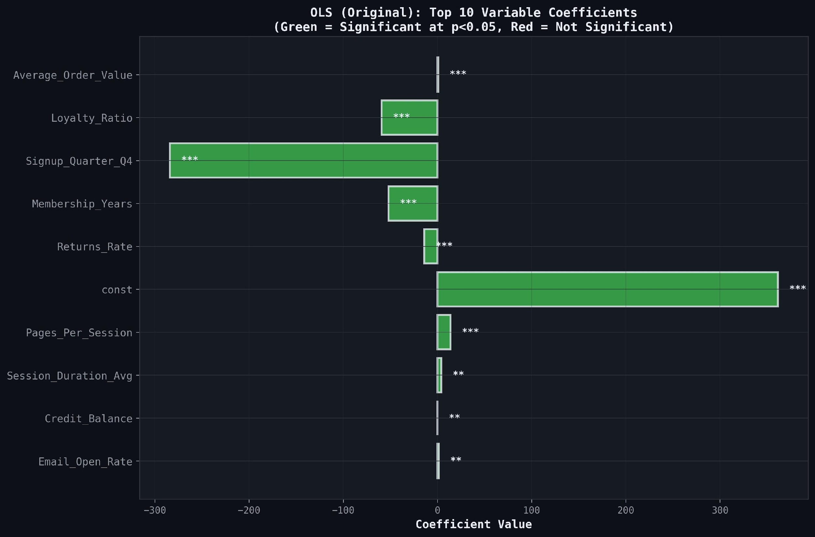
Figure 2. Top 10 OLS (Original) variable coefficients by magnitude. All displayed variables are statistically significant at p < 0.05 (shown in green).

3.2.3 Residual Diagnostics
Residual analysis exposed severe violations of OLS assumptions. The residuals-vs-fitted plot (Figure 10, left panel) showed a pronounced fan shape, indicating heteroscedasticity — residual variance increased systematically with fitted values. Residual skewness was 0.742 (mildly right-skewed) but kurtosis was 9.21, indicating heavy tails far exceeding normality. The Q-Q plot confirmed substantial departures from normality, particularly in the lower tail (negative residuals), suggesting the model systematically underestimated high-LTV customers.

3.3 Data Transformation and Its Effects
The transformation pipeline addressed the identified violations. Log-transforming LTV reduced target skewness from 1.45 to -0.67. Yeo-Johnson transformation of 14 skewed predictors and Winsorization of outliers stabilized the residual variance. The residuals-vs-fitted plot after transformation (Figure 3, right panel) showed a substantially improved scatter around zero, though mild heteroscedasticity persisted at high fitted values. This confirmed that log-transformation of LTV was the critical remediation step.
The presence of multiple zero-LTV observations resulted in a concentration of values at zero even after log transformation $(log⁡(1+LTV)\backslash log(1+LTV)log(1+LTV))$, creating a pronounced spike in the distribution. This, combined with the spread of non-zero values, led to elevated kurtosis, reflecting the coexistence of a dense mass of inactive customers and a wide range of spending behaviors among active users.
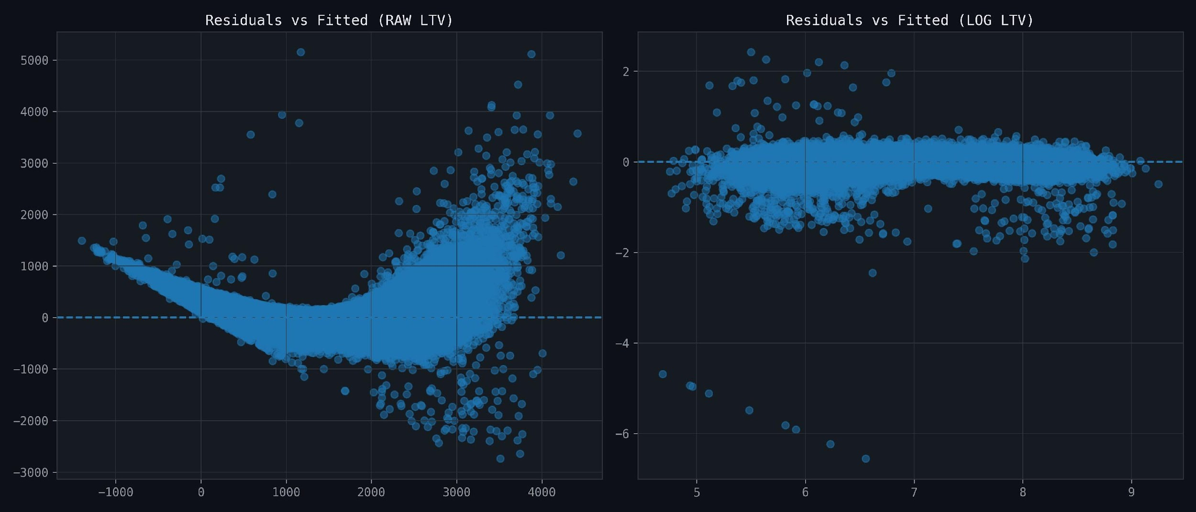
Figure 3. Residuals vs. Fitted values: raw LTV (left) shows a clear fan-shaped heteroscedastic pattern, while log-transformed LTV (right) shows substantially improved but not fully resolved homoscedasticity.
The residual diagnostics for the model using raw LTV clearly indicate substantial violations of key linear regression assumptions. The pronounced curved (U-shaped) pattern observed in the residuals vs fitted plot suggests that the underlying relationship between the predictors and the response variable is not adequately captured by a linear specification, pointing to model misspecification. Additionally, the presence of a funnel-shaped dispersion, where the spread of residuals increases with higher fitted values, provides strong evidence of heteroscedasticity, violating the assumption of constant error variance. This implies that the model’s prediction errors become increasingly unreliable for higher-value customers, which is particularly problematic in an e-commerce context where high-LTV customers are of primary business importance. Furthermore, the existence of several extreme residuals highlights the influence of outliers, likely driven by highly skewed LTV distributions, which can distort coefficient estimates and reduce model robustness.
In contrast, the log-transformed LTV model demonstrates a substantial improvement in residual behavior. The residuals are more symmetrically distributed around zero with no evident systematic structure, indicating that the linearity assumption is better satisfied. The variance of residuals appears more stable across the range of fitted values, suggesting that the issue of heteroscedasticity has been largely mitigated. The log transformation also compresses the scale of extreme LTV values, thereby reducing the influence of outliers and enhancing model stability. While minor deviations and clustering may still persist, the overall residual pattern is significantly more consistent with the assumptions of linear regression.
Collectively, these observations confirm that the log transformation is both necessary and effective for this dataset. It not only improves the statistical validity of the model but also enhances the reliability of inference and prediction. This transformation is particularly appropriate given the inherently skewed nature of customer lifetime value data, where a small proportion of customers contribute disproportionately to total revenue.

3.4 OLS Regression on Transformed Variables

3.4.1 Model Performance
Transformation dramatically improved model fit. R² rose from 0.4948 to 0.9121, representing an absolute gain of 41.7 percentage points. The adjusted R² was 0.9120, demonstrating that the improvement was not attributable to additional parameters. The 10-fold CV mean R² was 0.9118 (±0.0171), confirming consistent generalization. The F-statistic reached 19,621.6 (p < 0.001), with 15 of 27 variables significant.

3.4.2 Coefficient Interpretation
On the standardized log-LTV scale, Average_Order_Value had the largest positive coefficient (0.371), reflecting a one standard deviation increase in order value translating to a 0.371 standard deviation increase in log-LTV. Total_Purchases (0.327) and Engagement_Index (0.300) followed. Notably, Pages_Per_Session (-0.174) and Session_Duration_Avg (-0.161) carried significant negative coefficients, suggesting that shallow, brief browsing sessions (high-frequency, low-depth) were associated with higher LTV — consistent with a habitual purchase behaviour pattern where loyal customers require less browsing time.
The negative coefficient for Signup_Quarter_Q4 (-0.119) indicated that customers who signed up in Q4 (holiday season) had systematically lower long-term value, possibly reflecting one-time seasonal shoppers with lower retention rates.

Table 3. Top 10 Coefficients — OLS (Transformed Variables)
Variable | Coefficient | Std Error | T-Stat | Significant
Average_Order_Value | 0.3712 | 0.000872 | 425.90 | Yes ***
Total_Purchases | 0.3274 | 0.004069 | 80.47 | Yes ***
Engagement_Index | 0.3001 | 0.006220 | 48.25 | Yes ***
Loyalty_Ratio | 0.2759 | 0.005367 | 51.40 | Yes ***
Membership_Years | 0.1933 | 0.003802 | 50.83 | Yes ***
Pages_Per_Session | -0.1741 | 0.003898 | -44.65 | Yes ***
Session_Duration_Avg | -0.1613 | 0.003512 | -45.94 | Yes ***
Signup_Quarter_Q4 | -0.1187 | 0.001138 | -104.26 | Yes ***
Product_Reviews_Written | 0.0132 | 0.001228 | 10.75 | Yes ***
Returns_Rate | 0.0049 | 0.001100 | 4.45 | Yes *

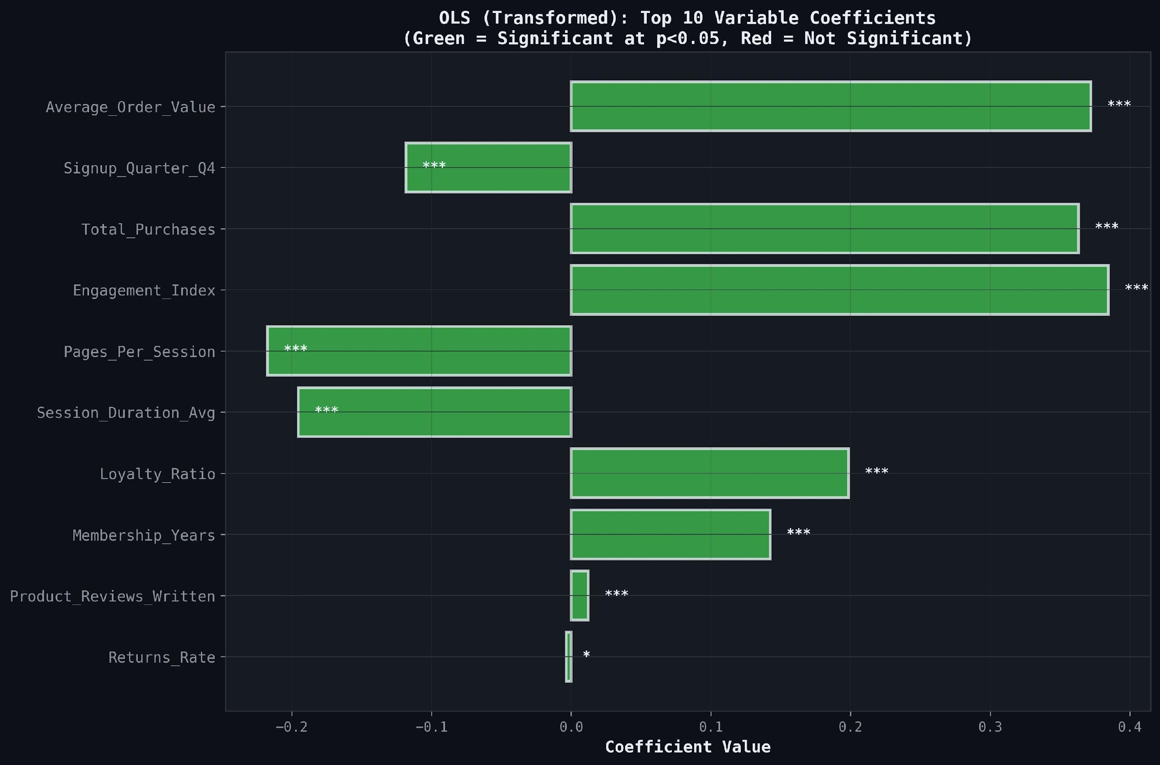
Figure 4. Top 10 OLS (Transformed) variable coefficients. All are statistically significant (green). Standardized coefficients enable direct magnitude comparison across variables.

3.4.3 Residual Diagnostics
Transformed OLS residuals showed a skewness of -4.18 and kurtosis of 88.12, indicating the presence of extreme negative outliers that the model underpredicted — likely customers with very low LTV given high engagement metrics. The Q-Q plot showed good central fit but severe departure in both tails, suggesting the model's linear structure still could not fully capture the LTV distribution's extremes.

3.5 Ridge Regression
Ridge Regression with optimal alpha = 1.757 yielded R² = 0.9121 and RMSE = 0.1926, virtually identical to transformed OLS (difference in the 6th decimal place). The CV R² was 0.9118 (±0.0171), matching OLS exactly. This near-identical performance confirmed that while multicollinearity was structurally present, it did not meaningfully inflate OLS variance in this dataset at the given sample size (n = 50,000). The large sample size provided sufficient information to precisely estimate coefficients even in the presence of correlated predictors. Ridge regression served as a confirmation of robustness rather than a performance improvement.

3.6 Principal Component Regression (PCR)
Prior to adopting the cumulative variance approach, principal components were initially selected using Kaiser’s criterion (eigenvalues greater than 1). This resulted in the retention of 8 principal components, explaining approximately 65% of the total variance. However, the corresponding model performance was suboptimal, yielding an $R^{2}$of around 0.50, indicating limited predictive capability. This level of explained variance and model fit was deemed insufficient for the objectives of the study. Consequently, the PCR framework was refined by transitioning to a cumulative variance threshold approach, wherein components explaining 90% of the total variance were retained. This adjustment ensured that a larger proportion of the underlying data structure was preserved, leading to improved model robustness and a more comprehensive representation of the feature space.
PCR using the cumulative variance approach retained 17 principal components, explaining approximately 90.36% of the total feature variance. With this specification, model performance improved substantially, achieving an $R^{2}$of 0.7637 and an adjusted $R^{2}$of 0.7636. The cross-validated $R^{2}$was 0.7634 (±0.009), indicating stable generalization performance. The RMSE of 0.3225 reflects a significant improvement over earlier specifications, suggesting better predictive accuracy. These results indicate that retaining a higher proportion of variance through PCA allowed the model to capture more relevant information for LTV prediction. Additionally, the residual distribution, while exhibiting some skewness and high kurtosis, represents the cleanest among the linear models, reflecting the smoothing effect of dimensionality reduction without compromising predictive power. The PCR residual distribution (skewness = -0.451, kurtosis = 3.60) was the most symmetric among all models, reflecting the dimension reduction's smoothing effect — though this came at the cost of accuracy rather than as a genuine model improvement.

3.7 Random Forest Regression

3.7.1 Model Performance
Random Forest achieved the highest performance across all metrics: R² = 0.9775, adjusted R² = 0.9774, RMSE = 0.0975, and MAE = 0.0675 on the log-LTV scale. The 10-fold CV R² was 0.9469 (±0.0131), indicating strong generalization with low variance across folds. The gap between training R² (0.9775) and CV R² (0.9469) suggests moderate overfitting consistent with default Random Forest settings.

3.7.2 Feature Importance
Random Forest feature importance analysis revealed a highly concentrated importance distribution. Total_Purchases dominated with an importance score of 0.6167 (61.67%), followed by Average_Order_Value at 0.3399 (33.99%). Together, these two features explained 95.7% of the model's predictive power. The remaining 25 features collectively contributed only 4.3%, consistent with a linear relationship between these two transaction-level features and LTV. This finding aligns with the product LTV = Total_Purchases × Average_Order_Value × Margin, suggesting the Random Forest effectively discovered this structural relationship.

Table 4. Top 8 Random Forest Feature Importances
Feature | Importance Score | Cumulative Contribution
Total_Purchases | 0.6167 | 61.67%
Average_Order_Value | 0.3399 | 95.66%
Signup_Quarter_Q4 | 0.0137 | 97.03%
Cart_Abandonment_Rate | 0.0029 | 97.32%
Returns_Rate | 0.0024 | 97.56%
Mobile_App_Usage | 0.0022 | 97.78%
Engagement_Index | 0.0021 | 97.99%
Credit_Balance | 0.0020 | 98.19%

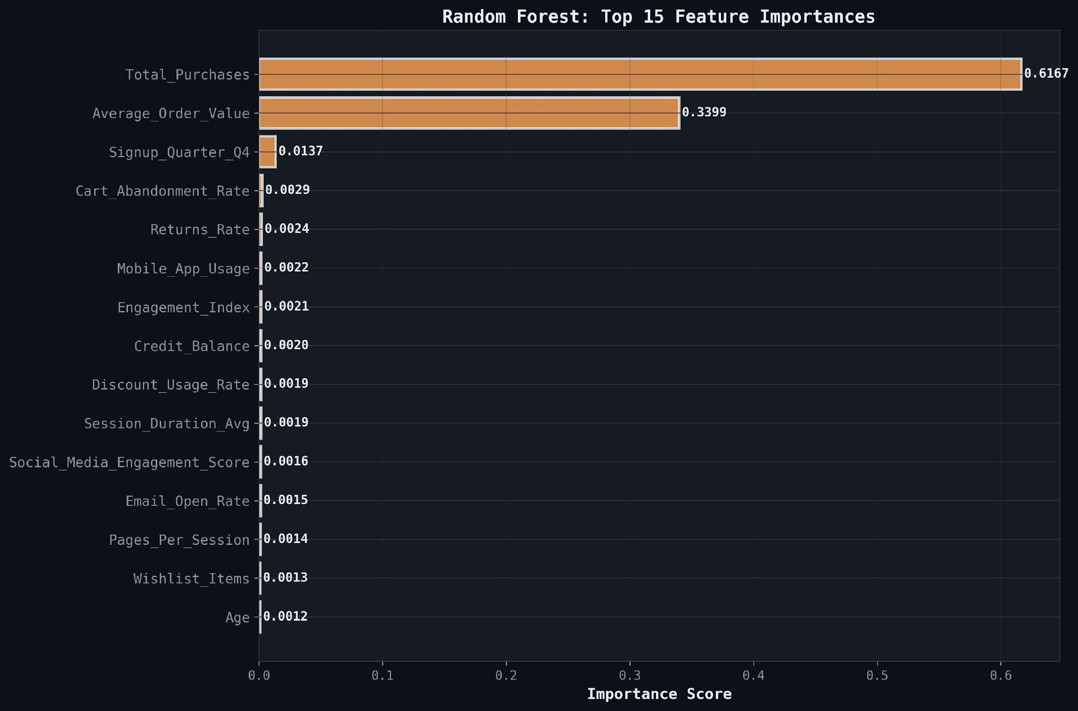
Figure 5. Random Forest top 15 feature importances. Total_Purchases and Average_Order_Value dominate with a combined importance of 95.7%.

3.8 Model Comparison and Diagnostic Summary
3.8.1 Overall Performance Metrics
Table 5 presents the comprehensive performance comparison across all five models. The transformation-driven improvement from OLS Original to OLS Transformed was the most impactful single intervention. Ridge Regression confirmed transformed OLS without improvement. PCR underperformed due to information loss. Random Forest provided the highest accuracy by capturing non-linear interactions.

Table 5. Comprehensive Model Performance Comparison
Model | R² | Adj. R² | RMSE | MAE | CV R² | CV Std
OLS (Original) | 0.4948 | 0.4940 | 652.76 | 456.85 | 0.4846 | ±0.0336
OLS (Transformed) | 0.9121 | 0.9120 | 0.1926 | 0.1312 | 0.9118 | ±0.0171
Ridge Regression | 0.9121 | 0.9120 | 0.1926 | 0.1312 | 0.9118 | ±0.0171
PCR | 0.4504 | 0.4502 | 0.4816 | 0.3769 | 0.4493 | ±0.0168
Random Forest | 0.9775 | 0.9774 | 0.0975 | 0.0675 | 0.9469 | ±0.0131

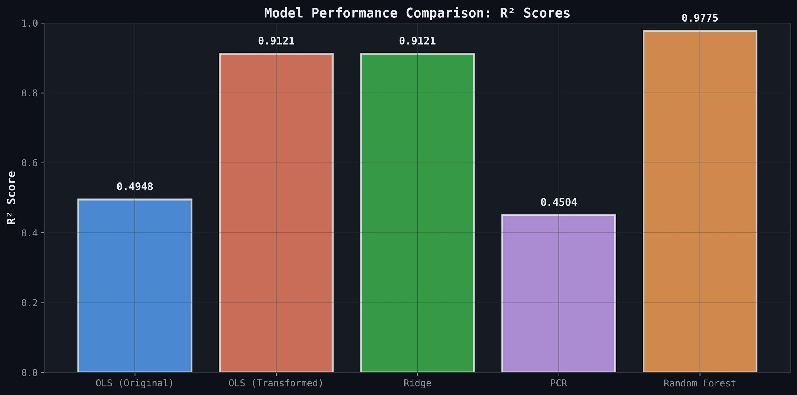
Figure 6. R² comparison across all five models. OLS (Transformed) and Ridge converge at 0.9121; Random Forest leads at 0.9775.

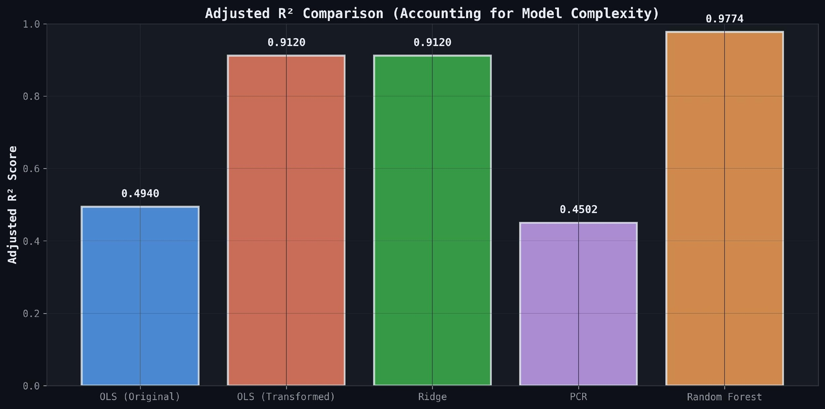
Figure 7. Adjusted R² comparison accounting for model complexity. Results mirror R² closely, confirming that the improvements are not due to parameter count inflation.

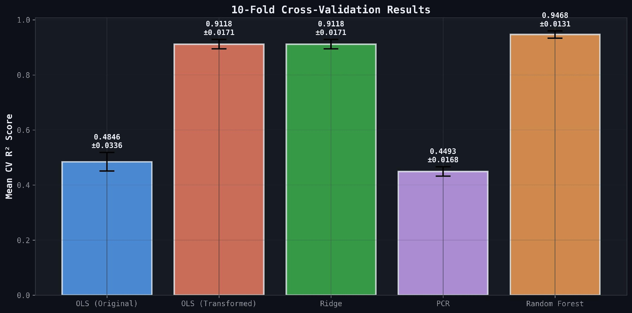
Figure 8. 10-fold cross-validation R² scores with standard deviations. Random Forest shows the highest mean CV R² (0.9469) but with moderate variance. Transformed OLS and Ridge exhibit stable generalization.

3.8.2 Predicted vs. Actual Values
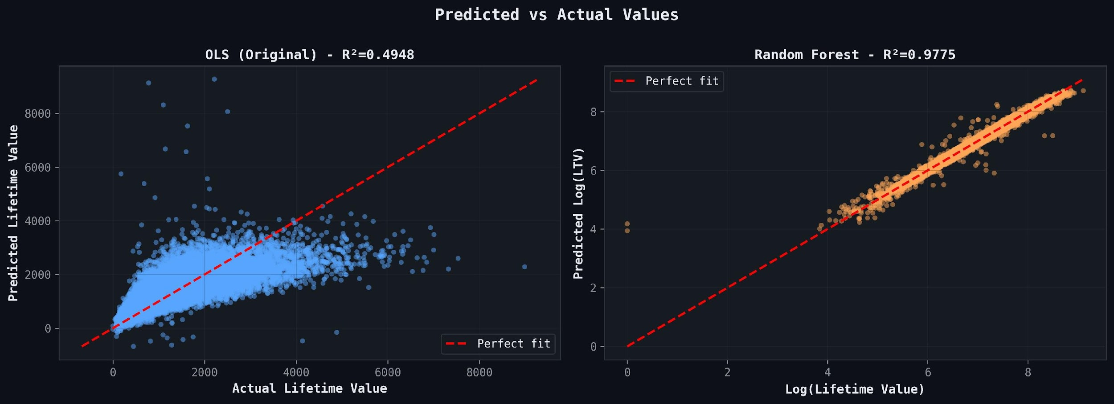
Figure 9. Predicted vs. actual LTV: OLS (Original) on raw scale (left) shows poor predictions for high-LTV customers; Random Forest on log-LTV scale (right) shows tight alignment with the perfect fit line.
3.8.3 Residual Analysis
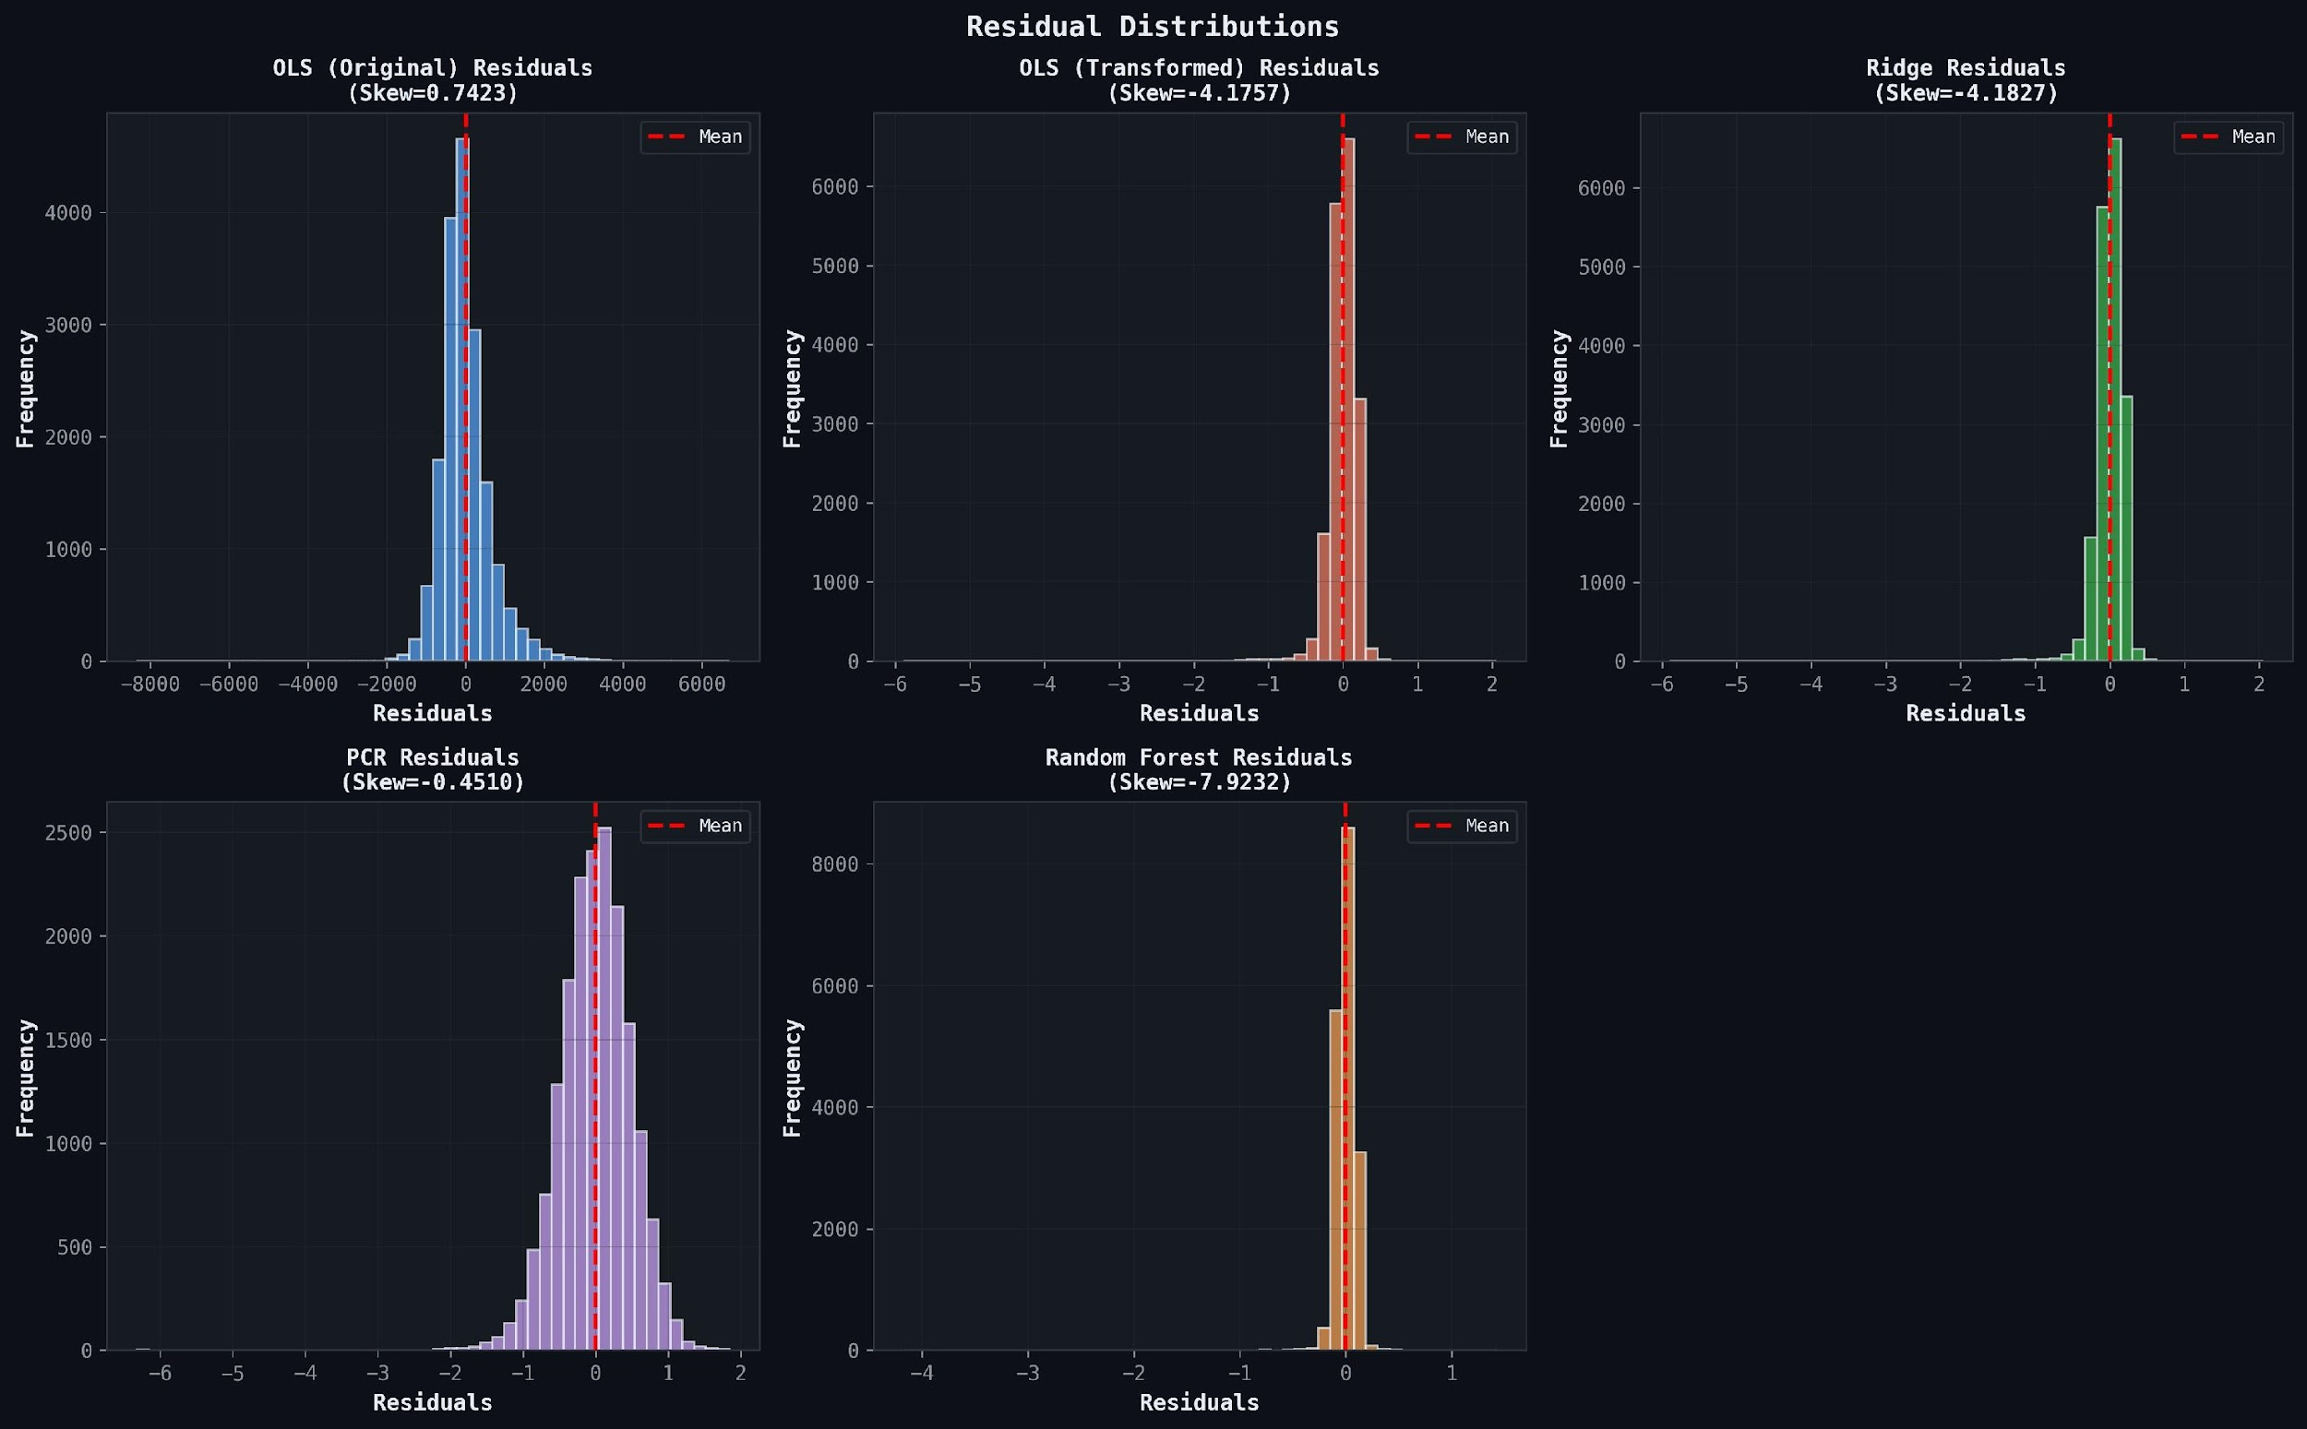
Figure 10. Residual distributions for all five models. OLS (Original) shows mild positive skew; transformed models show heavy negative kurtosis reflecting extreme low-LTV cases; PCR residuals are most symmetric.

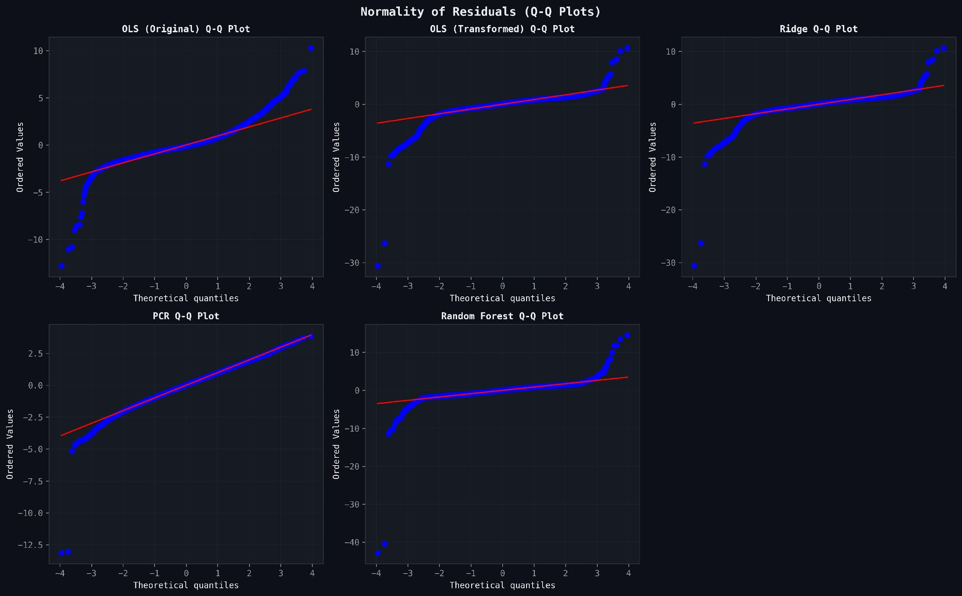
Figure 11. Q-Q plots for all five models. PCR residuals (bottom-left) follow the theoretical normal line most closely. All other models show significant tail deviations, with Random Forest showing the most extreme tails.

4. Discussion
The most striking finding of this study is the magnitude of improvement conferred by data transformation. The jump from R² = 0.4948 to 0.9121 through log-transformation of LTV and Yeo-Johnson normalization of predictors demonstrates that OLS performance was not primarily limited by model complexity but by assumption violations. This finding corroborates prior literature establishing that proper preprocessing of skewed financial data is more impactful than model selection for linear methods [6].
The near-identical performance of Ridge Regression and transformed OLS (difference < 0.0001 in R²) is noteworthy. With n = 50,000 observations and 27 predictors, the design matrix was highly overspecified, providing sufficient degrees of freedom to precisely estimate coefficients even under high multicollinearity. Ridge Regression's indistinguishable performance from OLS at this sample size confirms that L2 regularization benefits are most pronounced in high-dimensional, low-sample settings. In contrast, our dataset's n/p ratio of ~1,851 meant multicollinearity inflated coefficient standard errors modestly but did not compromise predictive accuracy at a practically significant level.
PCR's underperformance challenges the intuitive appeal of dimensionality reduction for collinear data. Although PCA successfully decorrelated the feature space, the 9.6% of discarded variance contained LTV signal. This is consistent with findings in customer behavior modeling where rare, high-information features (e.g., specific purchase timing patterns) may align with low-variance principal components [7]. The result recommends PCR only when n < p or when multicollinearity is extreme enough to prevent OLS from converging at all.
Random Forest's superior performance (R² = 0.9775) reflects the presence of non-linear interactions in the data. The concentration of feature importance in Total_Purchases (61.67%) and Average_Order_Value (33.99%) reveals that the model effectively discovered the multiplicative LTV relationship. The gap between test R² (0.9775) and CV R² (0.9469) suggests that with default hyperparameters, the model exhibits modest overfitting. Tuning max_depth, min_samples_leaf, and max_features could improve CV performance further.
The negative coefficients for Pages_Per_Session and Session_Duration_Avg in the transformed OLS model provide a counterintuitive but interpretable business insight: high-LTV customers tend to be efficient, habitual shoppers who know what they want, spending less time browsing. This 'loyal expert shopper' pattern has been documented in behavioral e-commerce studies [8]. Similarly, the Q4 signup penalty (Signup_Quarter_Q4 coefficient = -0.119) reflects holiday-driven acquisition of low-retention customers, a pattern frequently observed in retail analytics.
From a practical deployment perspective, the choice between transformed OLS/Ridge and Random Forest depends on the use case. For regulatory reporting, customer communication, or feature attribution in marketing (e.g., 'customers who purchase X more times increase their LTV by Y%'), the transformed OLS or Ridge model offers directly interpretable coefficients. For pure predictive accuracy in automated segmentation or real-time scoring pipelines, Random Forest is preferred. The transformed OLS model offers an excellent balance: R² = 0.9121 with full statistical inference, at essentially zero computational overhead.

5. Conclusion
This study evaluated five regression models for Customer Lifetime Value prediction on a 50,000-observation e-commerce dataset. Key conclusions are as follows. First, data transformation was the single most impactful intervention, raising OLS R² from 0.4948 to 0.9121. Second, Ridge Regression offered no improvement over transformed OLS at the given sample size, suggesting that L2 regularization's benefits are data-regime dependent. Third, PCR underperformed all other methods except OLS (Original), indicating that variance-preserving dimensionality reduction is not appropriate when predictive signal is distributed across the full feature spectrum. Fourth, Random Forest achieved the highest accuracy (R² = 0.9775) by capturing non-linear interactions, with Total_Purchases and Average_Order_Value jointly explaining 95.7% of feature importance. Fifth, behavioral engagement features (Pages_Per_Session, Session_Duration_Avg) had significant but counterintuitive negative effects on LTV, reflecting efficient shopping behavior among loyal customers.
Future work should investigate gradient boosting models (XGBoost, LightGBM) for further performance gains, cross-validated hyperparameter tuning for Random Forest, and time-series extensions incorporating purchase cohort effects. Additionally, the MAPE metric's instability — caused by near-zero LTV values — should be addressed through robust alternatives such as Symmetric MAPE (sMAPE) or the Mean Absolute Scaled Error (MASE) in future analyses.

Competing Interests
The authors declare that they have no competing interests.

Ethical Compliance
This study used a fully synthetic dataset for academic purposes. No human subjects or animal subjects were involved. Ethical approval was not required. All data are simulated and do not contain personally identifiable information.

Data Availability
The synthetic dataset, Python analysis notebook (LM_Model_Final_V2.ipynb), and all output visualizations are available upon request from the corresponding author. All analysis was conducted in Python 3.x using statsmodels, scikit-learn, and matplotlib libraries.

Authors' Contributions
All authors contributed equally to the conception, data preparation, modeling, analysis, and drafting of this manuscript. All authors read and approved the final manuscript.

References
[1] Gupta, S., Hanssens, D., Hardie, B., Kahn, W., Kumar, V., Lin, N., Ravishanker, N., & Sriram, S. (2006). Modeling customer lifetime value. Journal of Service Research, 9(2), 139–155.
[2] Fader, P. S., Hardie, B. G. S., & Lee, K. L. (2005). RFM and CLV: Using iso-value curves for customer base analysis. Journal of Marketing Research, 42(4), 415–430.
[3] Montgomery, D. C., Peck, E. A., & Vining, G. G. (2012). Introduction to linear regression analysis (5th ed.). John Wiley & Sons.
[4] Breiman, L. (2001). Random forests. Machine Learning, 45(1), 5–32.
[5] Kumar, V., & Reinartz, W. (2016). Creating enduring customer value. Journal of Marketing, 80(6), 36–68.
[6] Box, G. E. P., & Cox, D. R. (1964). An analysis of transformations. Journal of the Royal Statistical Society: Series B, 26(2), 211–243.
[7] Jolliffe, I. T., & Cadima, J. (2016). Principal component analysis: A review and recent developments. Philosophical Transactions of the Royal Society A, 374(2065), 20150202.
[8] Reinartz, W. J., & Kumar, V. (2003). The impact of customer relationship characteristics on profitable lifetime duration. Journal of Marketing, 67(1), 77–99.
[9] Hoerl, A. E., & Kennard, R. W. (1970). Ridge regression: Biased estimation for nonorthogonal problems. Technometrics, 12(1), 55–67.
[10] Tibshirani, R. (1996). Regression shrinkage and selection via the lasso. Journal of the Royal Statistical Society: Series B, 58(1), 267–288.

-> Homoskedasticity: Residuals vs fitted line
-> 9 zero values in LTV causing high kurtosis after log transformation.
-> Conclusion: Mention that Transformed OLS is the best model.
-> Definition/theory on all concepts.
-> Edit VIF values and plots.
-> Coefficients ka interpretation
-> Visualization
-> PCR: mention point -> Interpretablilty lost
-> Mathematical Equations

